

1
Learning Difficulties Information Guide
Numeracy



© State of Victoria (Department of Education and Training) 2022

Learning Difficulties Information Guide - Numeracy is provided under a Creative Commons Attribution 4.0 International licence. You are free to re-use the work under that licence, on the condition that you credit the State of Victoria (Department of Education and Training), indicate if changes were made and comply with the other licence terms, see: Creative Commons Attribution 4.0 International
The licence does not apply to:
- any images, photographs, trademarks or branding, including the Victorian Government logo and the DET logo; and
- content supplied by third parties.
Copyright queries may be directed to copyright@education.vic.gov.au

2

Contents

About this guide 4
Background 4
New strategies and initiatives 5
The difference between a learning difficulty and a learning disability 6
Legal responsibilities 6
Personalised learning and support planning 7
Numeracy learning difficulties 8
Why is numeracy important? 8
Characterising learning difficulties in numeracy 9
Identifying numeracy learning difficulties and dyscalculia 10
Subitising 11
Comparing approximate magnitudes 11
A three-phase maths assessment process 12
Numeracy intervention 14
Response to Intervention and numeracy learning difficulties 14
High Impact Teaching Strategies 15
Hallmarks of effective numeracy intervention 16
Adjustments for students with learning difficulties 18
Student support services 18
Case study - Year 5 student example 19
Learning difficulties and student wellbeing 21
Empowering students 21
Framework for Improving Student Outcomes (FISO 2.0) 22
Engaging with families 23
Bibliography and professional reading 24
Appendix 1.1: High Impact Teaching Strategy - Structuring Lessons 25
Appendix 1.2: High Impact Teaching Strategy - Explicit Teaching 26

3

About this guide

The Learning Difficulties Information Guide – Numeracy is a foundation for understanding learning difficulties in numeracy, including dyscalculia, and a guide for what teachers can do to support this cohort of students.
This guide sits alongside the:
- Learning Difficulties Information Guide – Literacy
- Learning Difficulties Information Guide
– School Leaders.
The school leaders guide contains information to help schools understand how supporting students with learning difficulties fits within the broader vision of the Education State.
This guide and the literacy guide are more specialised, designed to help build the confidence and practical capability of teachers to identify, assess and implement interventions to support students with learning difficulties in
day-to-day practice.
While the advice in all three guides is intended to help support students with learning difficulties, its application will help to improve the literacy and numeracy of all students (Gettinger & Stoiber 2007; Marston 2005).

Background
This guide was created in 2019 to support the Literacy and Numeracy Strategy Phase 2, which outlined Victoria’s plan to improve literacy and numeracy outcomes for all students.
It was updated in 2022 to reflect new strategies and initiatives including the:

- Disability Inclusion
https://education.edugate-cms.eduweb.vic. gov.au/school/teachers/learningneeds/Pages/ disability-inclusion.aspx
- Autism Education Strategy https://education.edugate-cms.eduweb.vic. gov.au/school/teachers/learningneeds/Pages/ Autism-Education-Strategy.aspx
- Diverse Learners Hub https://aus01.safelinks.protection.outlook. com/?url=https%3A%2F%2Fwww.vic.gov. au%2Fdiverse-learners-hub%2Fautism- student-resources&data=04%7C01%7CLia. Castorina%40education.vic.gov
- Learning Difficulties (teachers) - Numeracy https://www.education.vic.gov.au/Documents/ school/teachers/teachingresources/discipline/
english/reading/Numeracy-Guide.pdf

Disability Inclusion
The Disability Inclusion reforms provide increased support for students with disabilities through:
  - a tiered funding model for students with disability with additional funding for schools to help students with disability take part in their education on the same basis as their peers
  - a Disability Inclusion Profile - strengths-based process to help schools and families identify:
    - the student’s strengths and needs
    - the educational adjustments schools can make to help students with disability.
  - initiatives to help build knowledge and skills in inclusive education across the school system, and increase access to:
    - specialist expertise
    - coaching
    - professional learning
    - evidence-based guidance and resources
    - scholarships for school staff.
  - Inclusion Outreach Coaching to support schools to use inclusive education practices

Autism Education Strategy
Recognises that additional specific support is required to assist autistic students with their education and ensures that this strongly aligns with the Disability Inclusion package. It:
  - promotes and celebrates autism inclusion and diversity at the whole-school level
  - builds the capability of school leaders and staff to meet the educational needs of
autistic students
  - involves the student, families and experts in collaboratively planning for students’ education
  - supports autistic students’ health and wellbeing
  - supports autistic students’ individual education needs
  - strengthens accountability and transparency for students with disability.

Diverse Learners Hub
A key initiative of the Disability Inclusion reforms and flagship of the Autism Education Strategy.
The Diverse Learners Hub (DLH) is an online centre of excellence providing the best evidence-based advice and support for meeting the learning and wellbeing needs and aspirations of
diverse learners.

Learning Difficulties webpages
A key component of the DLH is the new suite of learning difficulties webpages covering three distinct categories:
- Parents
- Teachers – Literacy
- Teachers – Numeracy.
The new webpages will support our education workforce and parents/carers to better meet the educational needs and aspirations of diverse learners, including those with learning difficulties such as dyslexia and dyscalculia.
The webpages:
- provide evidence-based resources, information and guidance (with year-level examples) to support classroom best practice
- will empower students with learning difficulties and their families to engage in the education system and home-school partnerships with confidence and contribtue to meeting the educational needs, aspirations and wellbeing of diverse learners.

The difference between a learning disability and learning difficulty

Approximately 15–20 per cent of students in every school in every classroom will have a learning difficulty (AUSPELD 2014).
Learning difficulty is an umbrella term to describe students who are experiencing difficulty with learning because of a variety of reasons (for example, disability, living in out-of-home care) and who are unable to access the curriculum through high-quality instruction alone.
This group of students, if they are provided with greater knowledge and practice, are more than capable of closing the gap between them and their peers.
Understanding the reasons why a student may be experiencing difficulties while learning is an important first step to help them better access the curriculum.
Learning disabilities are a subset of learning difficulties and are classified as congenital, neurological differences (that may or may not be diagnosed) which include specific learning disabilities, such as dyslexia and dyscalculia.
Students with learning disabilities are predisposed to difficulties with their learning, no matter the circumstances they are born into,
their school environment or the quality of teaching they experience.
Not all students with neurological differences will present with a set of recognisable traits, which can make it hard to identify a learning disability.
It is likely, however, that students with learning disabilities will respond less effectually and more slowly to intervention compared to those with other learning difficulties.
For the purposes of this guide, ‘learning disabilities’ will be viewed as a subset of the larger group of students generally referred to as experiencing learning difficulties.
For more information visit Understanding types of learning difficulty (www.education.vic.gov.au/ school/teachers/teachingresources/discipline/ english/reading/pages/understandings.aspx)

Legal responsibilities
One in five Australians will have a disability at some stage in their lives. For some, the disability will be temporary. Others are affected for a lifetime. Whatever the case, everyone has the right to be an active member of their community and to have a say in the decisions that affect their lives.

As a teacher, your attitudes, words and actions have a huge impact on the lives of students with disability.

The Disability Standards for Education 2005 (the Standards) were developed under the Disability Discrimination Act 1992 (DDA). The definition of disability in the DDA includes physical, intellectual, mental health and learning disability.

The Standards clarify the obligations of education providers under the DDA and seek to ensure
that students with disability can access and participate in education on the same basis as other students.

School leaders and teachers should be aware of their obligations in supporting students with learning disabilities to ensure their compliance with the DDA and the Standards.

Among other things, schools are obliged to make reasonable adjustments to ensure students with learning disabilities can access education on the same basis as their peers.

Personalised learning and support planning

The DDA and the Standards in a nutshell Together, the DDA and the Standards help to ensure that Australian school students with disability get the same opportunities at school as everyone else.
- The DDA is Commonwealth legislation that aims to eliminate disability-based discrimination and promote equal rights, opportunity and access for people
with disability.
- The Standards help to clarify the DDA. They provide a framework for the educational rights of students with disability to enable them to access and participate in education on the same basis as other students.
(NCCD 2019)
To maximise engagement and outcomes for students with learning difficulties, a four-stage personalised learning and support planning process is recommended.
The four stages of Assess, Plan, Teach and Evaluate serve as a guide for identifying students’ learning strengths and needs and for designing, implementing and evaluating tailored teaching and intervention strategies, including the development of Individual Education Plans.

Individual Education Plans
An Individual Education Plan (IEP) describes the adjustments, goals and strategies designed to meet the educational needs of an individual student to enable them to reach their potential.
An IEP is a living document that is essential in guiding the educational planning and monitoring of a student’s unique learning needs.
Professional learning
Disability standards for education eLearning modules
Disability standards for education eLearning (www.education.vic.gov.au/ school/teachers/learningneeds/Pages/ dselearning.aspx)
- helps schools and other education providers understand their obligations under the DDA and the Standards
- is important to understanding the model applied to the nationally consistent collection of data on school students with disability.

IEPs are recommended for students with learning difficulties. An IEP:
  - supports schools in developing a meaningful learning program for students and to track progress against SMART goals
  - provides a means to share information between school, student, family and other support professionals
  - helps schools to determine how best to use resources to support students
  - promotes agency and student voice by involving the young person in the process
  - serves to establish the process by which teachers and schools are meeting their legal obligations for students with learning
disabilities under the Disability Discrimination Act 1992 and the Disability Standards for Education 2005.

Numeracy learning difficulties

In the information age we need to keep track of and process an unprecedented amount of numerical data. Numeracy can be described as the knowledge, skills and behaviours that allow us to use mathematics in a range of everyday contexts, including study, the workplace, and our personal lives. Yet despite the best efforts of
their teachers, some students will have a learning disability that affects their learning in numeracy (Butterworth 2005).

The more acute form of this disability is known as ‘dyscalculia’, from the Greek dys- (‘difficulty’) and the Latin calculare (‘to count’).

Why is numeracy important?
The application of numeracy is important for our participation in society and understanding of the world. We use numeracy every day, in all areas of our lives. Because life decisions are so often based on numerical information, students need to be numerate to make the best choices.
Throughout school, students are introduced to increasingly sophisticated and challenging numerical ideas and abilities, such as maths fluency, reasoning, modelling, and problem- solving. Grasping these numerical concepts enables students to engage with familiar and unfamiliar situations and make well-informed decisions (VCAA 2019).
While numeracy learning difficulties and dyscalculia have received less attention than other developmental learning disorders in Australia, international prevalence rates suggest that approximately eight percent of people worldwide have dyscalculia—rates comparable to those of dyslexia (Reeve 2019).
For more information visit Deciding if a student has a learning difficulty in numeracy https://education.edugate-cms.eduweb.vic.gov.au/ school/teachers/learningneeds/Pages/unpack- numeracy-learning-difficulty.aspx

Characterising learning difficulties in numeracy
In the past, learning difficulties in numeracy have been characterised as general cognitive problems (for example, low IQ). It is now understood that
a student may be experiencing difficulty in mathematics for a range of reasons, including:
Student related factors
  - chronic absenteeism
  - sensory impairment(s)
  - delayed acquisition of language
  - social-emotional difficulties
  - specific cognitive problems (for example, issues with working memory)
  - overlap with a literacy learning difficulty
Social and/or environmental factors
  - limited early language and literacy exposure
  - low socio-economic status
  - family history of learning disabilities
  - disrupted learning (for example, school refusal)
  - if English is not a student’s first language, or the primary language spoken at home, this may contribute to initial difficulties while the child masters the language.
Dyscalculia is regarded as a specific learning disability, resulting from differences in the brain that affects the typical acquisition of numerical skills (Butterworth 2019). The American Psychiatric Association DSM V (2013) defines dyscalculia
as a learning deficit associated with difficulties processing numerical information, learning arithmetic facts, and performing calculations.
In approximately 25 per cent of cases, dyscalculia overlaps with dyslexia (Butterworth 2005) and since many maths problems also rely on literacy and language skills (for example, arithmetic word problems) a learning difficulty in numeracy can be exacerbated by a learning difficulty in literacy.
There is no easy method for identifying students with a learning difficulty in numeracy, nor is there a ‘one size fits all’ approach to providing support to these students. Understanding each learner’s individual needs is critical to determine appropriate interventions and the different kinds of supports they require.


9

Identifying numeracy learning difficulties and dyscalculia

It is important that classroom teachers understand why a student is having difficulty with mathematics before devising and delivering interventions. Effective interventions for students
with delayed acquisition of basic number concepts differ from those for students with dyscalculia.

Figure 1: an example of a subitising exercise (top) and approximate magnitude exercise (bottom).
As explained previously, there are many reasons why a student might struggle with mathematics (Reeve & Waldecker 2017). Many assessment methods simply identify students with low achievement, rather than helping teachers to understand the nature of the difficulty itself.
Dyscalculia affects the typical acquisition of numerical abilities. Research has isolated two ‘markers’ that can help to identify students’ core number ability, specifically:
  - the ability to rapidly and precisely enumerate; that is, to establish the number of small sets of objects without explicitly counting
them (subitising)
  - the ability to efficiently compare the approximate magnitudes of quantities; for example, by identifying which set of squares contains more squares (approximate magnitude) (Butterworth 2019; Landerl 2019).
Both markers are indicators of capability in mathematics, and can be identified early in life.
Students exhibiting problems with the core number abilities of subitising and approximate magnitude may have dyscalculia and should be distinguished from students experiencing difficulties with learning for other reasons.
These abilities and the way they present in the classroom are explained in the following sections.

Subitising
The ability to rapidly enumerate small sets of objects at a glance, without explicit counting, is known as subitising.
Testing students’ subitising skills can help identify numeracy learning difficulties. Typically, when presented with small sets of objects (up to five), students can quickly and accurately name the number of objects in a set without needing to count them individually.
A student with dyscalculia, however, will not be able to do this quickly. They may need to count each object individually, saying the numbers aloud (‘One, two, three…’), sometimes pointing to the objects while they count.
The ability to subitise is associated with our ability to ‘recognise or operate on sets’ (for example, knowing that three dots represent a value of three, but also the symbol ‘3’). Since this ability is linked to a symbolic understanding of numbers, students with a subitising difficulty will struggle in situations where they are required to apply this type of understanding (in particular, mathematics).
Subitising also impacts a student’s ability to effectively compute answers to addition problems and to use appropriate problem-solving strategies.
Students who lack typical subitising abilities are at a distinct disadvantage mathematically. Their
acquisition of numerical abilities is inhibited, which in turn affects their acquisition of more complex mathematical concepts.
For more detailed information on the reasons students may experience learning difficulties in numeracy, visit the Learning Difficulties in Numeracy video series:
- Video 1 – Numeracy and the Brain (www.education.vic.gov.au/school/teachers/ learningneeds/Pages/professional-learning. aspx) An introduction to the neuroscience of numeracy learning difficulties and core number abilities.
- Video 2 – Numeracy and the Curriculum (www.education.vic.gov.au/school/teachers/ learningneeds/Pages/professional-learning. aspx) Factors underlying numerical understanding in the primary and secondary mathematics curriculum.

Comparing approximate magnitudes
The ability to efficiently compare the approximate magnitudes (sizes) of quantities is also considered an indicator of numerical ability and can help teachers identify students who may have a learning difficulty in numeracy.
Teachers can check this ability by assessing the speed and accuracy with which students identify the relative magnitude of two numerical values, for example, ‘Which quantity/number is larger?’
In the bottom example (Figure 1), a student would be asked to identify the array with the most squares. Students with dyscalculia, compared to their peers, are less accurate and significantly slower in making comparison judgements like this. As with subitising, their ability to compare approximate magnitudes of quantities is a strong predictor of their abilities in mathematics (Butterworth 2019).
The ability to quickly and efficiently compare the relative magnitude of numbers or quantities is an important conceptual competence associated with estimation abilities and, in turn, the ability
to approximate answers. In absence of this ability, mathematical problems tend to be solved procedurally, relying solely on rote processes.
For more information visit
Deciding if a student has a learning difficulty in numeracy
https://education.edugate-cms.eduweb.vic.gov.au/ school/teachers/learningneeds/Pages/unpack- numeracy-learning-difficulty.aspx
Example of how to unpack a numeracy learning difficulty using information https://education.edugate-cms.eduweb.vic.gov.au/ school/teachers/learningneeds/Pages/unpack- numeracy-learning-difficulty-example.aspx

11

A three-phase maths assessment process
Once a student has been identified as experiencing difficulties in numeracy, teachers can use the following three-phase process as a guide for understanding their needs and for developing and delivering appropriate interventions.

First phase
In the first phase of assessing a student, a teacher should observe and record the student’s maths performance over a set period (for example, between two to six months).
During this phase, teachers should focus on using the Victorian F-10 Mathematics Curriculum as a measure of ability, assessing a student’s:
  - number skills
  - mastery of number facts
  - calculation skills
  - understanding of maths concepts.

Assessment resources
The department provides a range of resources to assist teachers to understand a student’s learning needs in the Numeracy Portal (www.education. vic.gov.au/school/teachers/teachingresources/ discipline/maths/Pages/default.aspx)
Resources include:
- The Mathematics Teaching Toolkit
- The Mathematics Online Interview
- Birth to Level 10 Numeracy Guide
The aim is to inform intervention by creating a profile of a student’s strengths and identifying areas for growth.
Teachers should also aim to collect information about other factors that could explain a student’s maths performance (such as missing key lessons, or disruptions at home).
For more information visit Creating a numeracy profile (https://education.edugate-cms.eduweb. vic.gov.au/school/teachers/learningneeds/Pages/ create-numeracy-profile.aspx)

Second phase
In the second phase, teachers can administer more detailed maths assessment based on observation, to isolate a student’s key numerical abilities.
Teachers may consider implementing a ‘dynamic assessment’ approach to better understand the student’s ability.

Third phase
The third phase involves identifying and using appropriate interventions based on data and informed by teacher observations from the first two phases.
All interventions should use the Victorian F-10 Mathematics Curriculum as the basis for teaching students skills and knowledge.
What does dynamic assessment look like?
Dynamic assessment involves the teacher constructing a ‘mini learning progression’ within a relatively narrow maths domain.
A teacher might, for example, choose to focus on simple word problems.
The steps required to solve a problem are specified to the student, and the teacher and student collaborate to solve the problem. The student may not have the competence to solve the entire problem independently, but with help from the teacher, can complete the steps, one by one, to solve the problem.
The teacher might use prompts such as, ‘Okay, what do we do now?’ or ‘What do you think
we need to do next?’, handing the student responsibility to then solve like problems.
During this exercise, the teacher can also gauge the student’s learning needs, specifically the nature and amount of help needed to solve problems independently.
The ability to transfer skills to different problems, provides an index of what is learned and a measure of learning potential (students with dyscalculia will find it difficult to apply learning to new problems, even when they appear to have cemented a skill).
More information about the frequency, intensity and nature of tiered intervention for learning difficulties in numeracy can be found in the following section.

For more detailed information on identifying and assessing students with numeracy learning difficulties, including dyscalculia, visit the Learning Difficulties in Numeracy video series, specifically:
- Video 3 – Characteristics of Dyscalculia (www.education.vic.gov.au/school/teachers/ learningneeds/Pages/professional-learning. aspx) Specific advice for teachers about recognising the characteristics of dyscalculia and supporting students with dyscalculia in the classroom.
- Video 4 – Classroom Assessments (www.education.vic.gov.au/school/teachers/ learningneeds/Pages/professional-learning. aspx) Advice about assessment practices and clearly establishing the purpose of these assessments (for example, assessment for support, intervention or understanding).

For more information visit

Dynamic assessments like this can help students to internalise problem-solving concepts
and procedures.
Teaching students with numeracy learning difficulties
https://education.edugate-cms.eduweb.vic.gov.au/
school/teachers/learningneeds/Pages/students- numeracy-learning-difficulties.aspx

Examples of teaching students with numeracy learning difficulties
https://education.edugate-cms.eduweb.vic.gov.au/
school/teachers/learningneeds/Pages/learning- difficulties-teaching-examples.aspx

13

Numeracy intervention

There is no ‘one size fits all’ approach to supporting students with learning difficulties in numeracy.
Understanding each student’s individual learning needs is critical to determining appropriate interventions, and students with different kinds of numeracy learning difficulties require different kinds of learning support and interventions.
Given the range of skills and abilities involved in solving mathematical problems, a comprehensive assessment is often required to evaluate the factors affecting students’ maths skills. This is key to understanding the nature of students’ needs and to deciding upon the appropriate form of support.
Careful analysis by teachers of students’ numeracy performance (or ‘maths profile’) over time can
help them to identify learning needs, plan and deliver appropriate support. In making evaluations, teachers should note how students respond to intervention and consider the cause/s of difficulties. They can then tailor support accordingly.

Response to Intervention and literacy learning difficulties
The Response to Intervention (RTI) framework can be helpful for thinking about how to implement approaches to support students with learning difficulties. RTI is a framework of academic support often embedded within a Multi-tiered
System of Support, alongside School-wide Positive Behaviour Support. It divides support into three tiers of increasing intensity, organised according to need (Figure 2).
RTI provides a useful model to consider how best to embed academic support for students with learning difficulties within a school-wide approach to teaching and learning. The RTI framework is a functional, dynamic means of identifying students who are struggling with numeracy, based on how well they are responding to the instruction or interventions being provided at each tier.

Tier 3
(Individualised)

Tier 2
(Targeted)

Tier 1
(Whole-school)

Intensive, individualised instruction for students needing additional support to access and engage with the curriculum. This will comprise approximately 1-5% of students. Student support services may be included in the collaborative learning team supporting the student.

Targeted intervention for select identified students is delivered at a classroom level or in small groups. This will comprise approximately 5-15% of students. Students are provided with additional support to help them succeed in a general education classroom.

Teachers have opportunities to design whole-class instruction that meets the needs of as many students as possible. All students receive high-quality, differentiated instruction. Classroom teachers gather evidence about which students are responding
to Tier 1 instruction and which students require additional support.

Figure 2: Response to Intervention tiers of academic support (adapted from Buffum, Mattos, & Weber 2012).

Figure 3 describes how the tiered framework model can be used to identify and support students needing numeracy intervention.

Tier 1 – All students receive high-quality, differentiated instruction in the classroom. HITS are effective for all students at Tier 1, including students with learning difficulties.
Students who do not respond adequately to Tier 1 are identified and elevated to Tier 2.
Tier 2 – Supplementary support is provided to students (in addition to Tier 1 instruction). The nature of the support depends on the nature of the student’s learning difficulty.
A student may have a learning disability (such as dyscalculia), a high rate of absenteeism, disrupted learning, for example, due to placement in out-of-home care, specific cognitive problems (such as problems with working memory), or simply delayed progression.
For some students exhibiting delayed progress, small-group sessions targeting specific skill areas may be appropriate, however, students with dyscalculia will gain most benefit from the targeted, individualised, one-to-one programs described in Tier 3.
Tier 3 – Students who do not respond adequately to Tier 1 instruction and Tier 2 intervention (or who have been identified as having dyscalculia) will benefit from Tier 3 intervention.
Intervention strategies at Tier 2 address the individual needs of the students. At Tier 3, these strategies are delivered with greater intensity, frequency and duration. It is likely that intervention support will need to be delivered on a one-to-one basis.
For students with dyscalculia, interventions that make use of tangible materials (for example, wooden counting blocks) and other non-symbolic forms that represent numbers (for example, special number lines) help to reinforce relationships with symbolic forms.
Figure 3: Using Response to Intervention as a tool for identification and support.

15

High Impact Teaching Strategies
The High Impact Teaching Strategies (HITS) are 10 instructional practices that reliably increase student learning. For students with learning difficulties in numeracy, the HITS represent a collection of evidence-based strategies to help support teaching and learning in numeracy.
For example, research conducted into effective numeracy intervention shows that logically sequenced instruction (Structuring Lessons) and instructions that directly address the information a student needs to learn (Explicit Teaching) are highly effective at helping students with learning
disabilities access maths content (Fuchs et al. 2008).
Teachers, who know their students and their students’ learning styles well, can readily judge whether HITS or another strategy will work best to teach a particular concept or skill.
Note, however, that using HITS to teach any concept or skill reliably increases the chance that students will learn it, regardless of whether they have a learning difficulty.
Appendix 1.1: Structuring Lessons and Appendix 1.2: Explicit Teaching provide more detailed information about two of the HITS. In addition, the department’s Excellence in Teaching and Learning (www.education.vic.gov.au/Documents/ school/teachers/support/high-impact-teaching- strategies.pdf) resource provides overviews and examples that illustrate each of the 10 strategies in action.

Hallmarks of effective numeracy intervention
Teachers are best-placed to understand the learning needs of their students and the most appropriate types of interventions. Fuchs et al. (2008) suggests seven guiding principles for planning effective numeracy intervention:
- Instructional explicitness where teacher instruction directly addresses the information a child needs to learn.
- Transparent instructional design that minimises confusion for a student about what they need to do. Explanations are clear, precise and ordered logically.
- A strong conceptual basis is needed for all procedures. When students have a genuine understanding of what they are learning, gaps in learning are less likely to develop.
A strong conceptual basis also helps students maintain skills and reduces difficulties with the integration of skills.
- Skill practice is appropriate only once a thorough understanding of the target concept has been established.
- A cumulative review should be conducted regularly. This should include what has just been taught and also what was known prior.
- Intrinsic and extrinsic motivators can help students to focus and demonstrate positive behaviours. Helping students to recognise the value or relevance of what they are learning encourages intrinsic motivation.
Praise or rewards are examples of extrinsic motivation.When a student becomes convinced a skill or activity is too difficult for them, not relevant or experiences repeated failure, they may start to display avoidance behaviours or signs of stress.
- Ongoing progress monitoring to determine whether the intervention is effective for the student. Teachers can utilise the Victorian F–10 Mathematics Curriculum and administer tests to assess specific concepts/applications or calculations. These assessments can be short, lasting only a few minutes, helping teachers and students avoid ‘testing fatigue’.

17

Intervention
For detailed information on interventions for students with learning difficulties, including dyscalculia, visit the Learning Difficulties in Numeracy video series:
- Video 5 – Intervention Strategies (www.education.vic.gov.au/school/teachers/ learningneeds/Pages/professional-learning. aspx) Evidence-based intervention strategies for students with learning difficulties in numeracy. The video provides intervention advice relating to:
  - core number
  - arithmetic
  - word problems
  - fractions
  - algebra
Examples of targeted intervention include:
  - teaching students the link between
non-symbolic number arrays and the symbols and words used for numerosities (for example, the number three can be represented by
the word ‘three’, the symbol ‘3’, or as a set of objects: • • •)
  - teaching for a better understanding of place value and its use in multi-digit subtraction.
In both cases, the use of concrete materials that can be manipulated (such as wooden counting blocks) can help students experiencing difficulties to understand concepts and use them in arithmetic calculation.
Students with dyscalculia, in particular, do not have an abstract view of numbers and cannot immediately picture an array of objects or dots when seeing a symbol for a number. Repeated association between tangible materials and symbols through matching tasks, and through using the physical objects to perform arithmetic operations, helps to build the link between
non-symbolic and symbolic numbers.

For multi-digit subtraction, students can use wooden counting blocks (representing units, tens and hundreds) to perform a calculation— exchanging a hundred block for 10 x ten blocks and a ten block for 10 x one blocks. This can help to build a better understanding of the decimal
properties of numbers for students with dyscalculia after numbers than an abstract procedure involving ‘borrowing’ and crossing out of digits.

Adjustments for students with learning difficulties
In addition to targeted interventions, certain adjustments can help students get the most out of classroom instruction. Accommodations can also be made in relation to undertaking assessment tasks and completing school work (including projects, in-class tasks and homework).
Table 1 lists some potential strategies, which will vary depending on a student’s particular learning needs.

Student support services
Student support services (SSS) assist children and young people facing barriers to learning by providing a range of strategies and specialised support at the individual, group, school
and area levels.
SSS comprise a broad range of professionals employed by the department, including:
  - psychologists
  - speech pathologists
  - social workers.
SSS staff work as part of an integrated health and wellbeing team within areas of schools, focusing on providing group-based and individual support, workforce capacity-building and specialised services.
The SSS Referral Process (www.education.vic.gov. au/Documents/school/principals/spag/safety/ SSSrefprocess.pdf) identifies children and young people with the greatest need, and matches student/school needs with the expertise of SSS team members.

Adjustments to help students get the most out of classroom instruction include: | - simplified worksheets that build on the student’s mathematics skills  - highly explicit, direct instructions  - displaying task instructions on a whiteboard  - instructions broken down into smaller steps  - additional opportunities for practice and questions  - individual assistance with problems presenting challenges.
Environmental adjustments can include: | - a desk close to the teacher  - limiting distractions while the student is working.
Adjustments to help students fully demonstrate  their knowledge when being assessed, and/or when completing school work include: | - assistive technology (such as calculators, or graded online maths tasks where progress is based on success)  - keeping tangible materials readily to hand  - additional time to complete work.
Table 1: Examples of reasonble adjustments and accommodations to support students with learning difficulties.

Case study - Year 5 student example

Improvements to teaching practice and student learning are strongly dependent on effective implementation within an evidence-based improvement cycle.
The four stages of the FISO Improvement Cycle support teachers to focus on better outcomes for all students.
It can be used at different levels, from the
whole-school to the classroom and over different time periods, from four-week to annual cycles.

Learning difficulties in the classroom | Connections
Mason is a Year 5 student. Mason’s previous end-of-year report indicates they are 12 months behind their peers in maths.  The class is currently learning about decimal fractions. Mason’s teacher notices that Mason finds it difficult to understand and use place values (such as hundredths, thousandths) accurately. The teacher also notices that Mason will often use their fingers to count out maths solutions and that they have trouble telling time, especially on analogue clocks. Mason also finds it difficult to apply maths concepts to new problems, even when they appear to have just cemented the skill.  The teacher decides to follow Mason’s maths performance closely over the next two months and to build a profile of their strengths and areas for growth. The teacher sets aside time for more detailed, dynamic assessments to isolate Mason’s numerical abilities.  At the end of the two months, the teacher feels confident that they have a better understanding of Mason’s numeracy needs. The teacher finds that Mason has difficulty understanding the relationship between symbolic and non-symbolic numbers (for example, understanding that 50 cents is equal to half of a dollar) and that they often misunderstand the meaning of operational language and notation (for example, what the word ‘equivalent’ means and confusing + and - ). | Evaluate and diagnose  - Identify if the student has a numeracy learning difficulty (page 10)  - Collect and use data and evidence to consider reasons for a student’s performance  - Create a numeracy profile  - What does the student need to learn next?  - How will you sequence what they need to learn? Certain knowledge and skills may need to be developed before the student can demonstrate others or meet numeracy goals.
The teacher meets with the school’s numeracy leader to review examples of Mason’s work and discuss their observations. Based on this data, the pair prioritise some immediate numeracy goals including:  - advancing Mason’s mastery of number facts (for example, that 5 + 3 = 3 + 5)  - increasing Mason’s familiarity with maths terminology and notation. They also set some long-term numeracy goals including:  - improving Mason’s ability to recognise and operate on sets (for example, knowing that three dots represents a value of three, but also the symbol ‘3’)  - embedding Mason’s understanding of the relationships between symbolic and non-symbolic numbers. | Prioritise and set goals  - Set immediate and long-term goals in the  context of understanding need and required support  - What organisational skills will you teach the student to develop their capacity to teach themselves?

Learning difficulties in the classroom | Connections
The teacher decides to create a vocabulary bank with definitions of maths terminology and examples that Mason can add to throughout the year. The teacher decides that this practice would be beneficial for all students, and incorporates it into their approach to teaching new units (Tier 1).  The teacher also introduces concrete materials to help represent problems using the maths groups in the classroom. During this group work, the teacher works with Mason cutting, folding and manipulating wooden unit blocks to help Mason cement the association between symbolic and non-symbolic numbers (Tier 2).  The teacher continuously monitors Mason’s progress throughout the term using dynamic assessments. These ‘mini learning progressions’ help the teacher to get a sense of how Mason is responding to the interventions and help Mason to internalise problem-solving concepts and procedures as the two collaborate to solve problems (Tier 3).  The teacher records their planning for Mason in an Individual Education Plan (IEP). | Develop and plan  - Develop a plan of action that details what will be done, when, where and with what support  - Use RTI to support numeracy learning difficulties (page 14)  - Use dynamic assessments (page 13)  - Develop an Individual Education Plan (page 7)  - How will you develop the student’s attitude towards numeracy and themselves as learners and users of numeracy and maths?
The teacher identifies the criteria that will be used to evaluate the impact of the IEP:  - increased familiarity with key terminology and accuracy of use (including notation)  - improvement in Mason’s ability to draw information from word problems  - increased independence in performing procedures  Following six weeks of intervention, the teacher and the Learning Specialist meet to review how Mason is responding to these interventions.  The teacher has observed improvement in Mason’s knowledge of key terminology and accuracy when applying relevant procedures, but notes that issues with their understanding of the relationship between symbolic and non-symbolic number still remain.  Nonetheless, Mason is responding well to the interventions and is making incremental, but consistent progress. Mason’s teacher and the team decide to continue with these intervention strategies until the end of the term when they will meet again to review Mason’s progress. | Implement and monitor  - Continue to monitor student progress and evaluate the student’s response to instruction/ intervention  - What would you expect the student to know, understand or be able to do if adjustments were successful? This includes short-term expectations (week to week) as well  as long-term (month to month).  - Encourage each step in the student’s knowledge or skill and fluency by providing scaffolding and modelling.

Learning difficulties and student wellbeing

Students with learning difficulties often face daily struggles at school as they attempt to deal with various related challenges. Research suggests that students with learning difficulties are at greater risk of having a poor sense of academic self-concept and may hold negative beliefs about themselves that are directly linked to their performance in class, such as ‘I am no good at reading’, ‘I can’t spell’, or ‘I am stupid’ (AUSPELD 2014).
While students with high self-esteem are typically more adaptable and do better in social environments, students with learning difficulties
who have low self-esteem tend to be less effective in engaging with others, experience feelings of powerlessness, feel disconnected from their peers, and have difficulty coping with setbacks (Hattie 2009).
Experiencing low self-esteem/efficacy for long periods of time can also increase the possibility of developing mental health issues such as anxiety, depression, and behavioural problems.
Students with learning difficulties may become withdrawn, appear disengaged, disruptive, rude or even aggressive as a result of the frustration they may feel not being able to keep up with the demands of the classroom.
These behaviours often become more pronounced as students become older, as their identity
and sense of self-worth becomes increasingly associated with their experiences of academic and social success.
On the other hand, when students begin to cultivate a positive self-view and feel connected to their peers, teachers and their learning, there is a marked improvement in academic achievement (Suldo, Thalji & Ferron 2011; Howell 2009).

Empowering students
Students’ success is strengthened by a robust sense of self-efficacy; that is, a firm belief in their ability to succeed at school. This sense of achievement in their learning and what students see as the meaning and purposefulness of their actions, come together to build a strong sense of agency and self-determination.
Developing a strong sense of agency and
self-efficacy is particularly important for students with learning difficulties, who are more vulnerable to feelings of powerlessness and that they have limited control over their learning and futures (AUSPELD 2014).
For more information visit
Helping students to become independent learners in numeracy
https://education.edugate-cms.eduweb.vic.
gov.au/school/teachers/learningneeds/Pages/ independent-learners-numeracy.aspx
Monitoring students’ numeracy progress https://education.edugate-cms.eduweb.vic.gov.au/ school/teachers/learningneeds/Pages/monitor- student-progress-numeracy-difficulties.aspx

Framework for Improving Student Outcomes 2.0
The Framework for Improving Student Outcomes (FISO) is an evidence-based framework that aims to enhance student outcomes in Victoria through supporting system-wide school improvement.
FISO 2.0 aims to further enhance schools’ effectiveness in achieving positive learning and wellbeing outcomes for every student.
The focus on improving students’ learning and wellbeing recognises that:
- students’ ability to learn is influenced by their wellbeing

students’ wellbeing is influenced by their engagement learning.
The redesigned framework:
- de-clutters the original FISO to help schools focus on what matters most
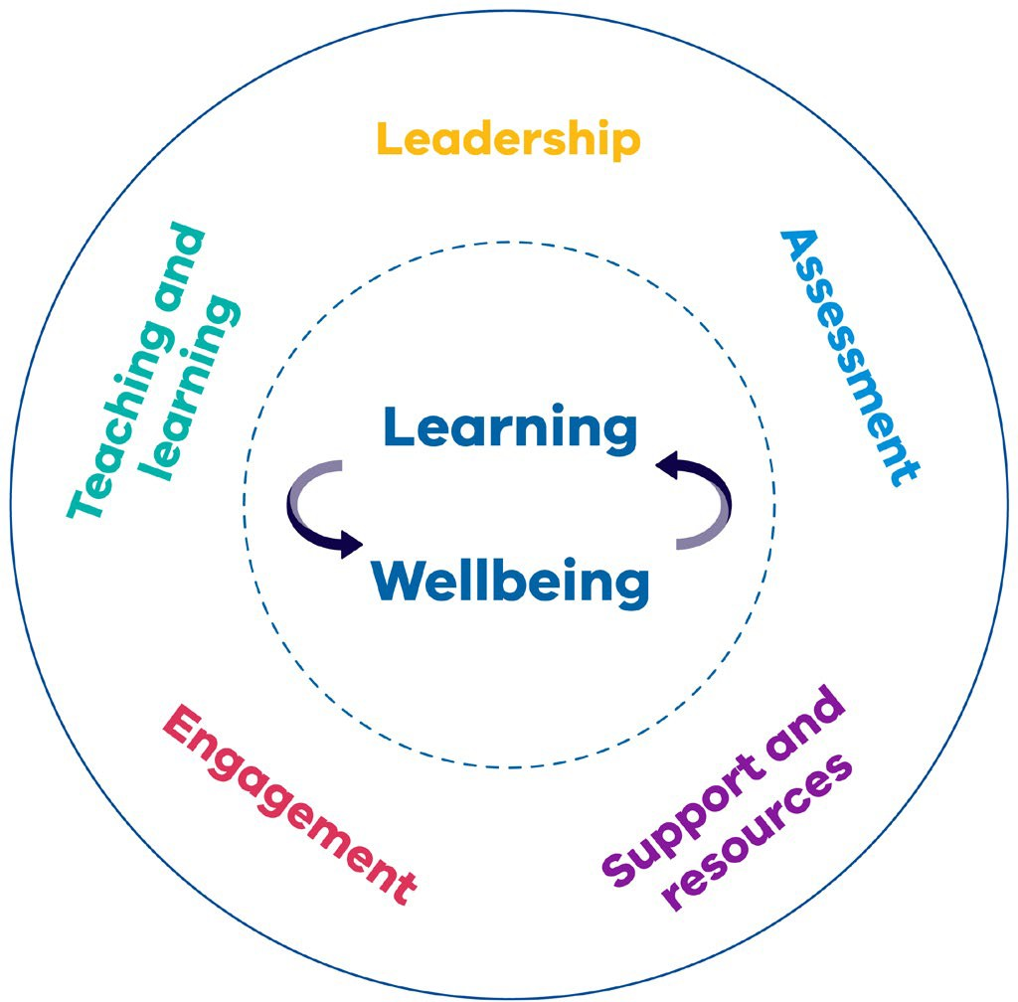
- elevates the importance of wellbeing both as an enabler of learning and as an outcome in its own right
- aligns to broader initiatives of the Victorian Government in supporting learning and wellbeing to strengthen coherence across disability inclusion, mental health and teaching and learning
- represents outcomes and elements that have been established in a contemporary and broader evidence-base
- provides specific and refined practice and outcome indicators to support schools’ self-evaluation.
For more information visit FISO 2:0
https://www2.education.vic.gov.au/pal/fiso/policy

Amplify (www.education.vic.gov.au/Documents/ school/teachers/teachingresources/practice/ Amplify.pdf) is a practice guide created by the department for school leaders and teachers.
It presents an evidence base and practical
school-based examples to help school communities explore and enhance their understanding of student voice, agency, and leadership - the key elements for empowered students.

Engaging with families
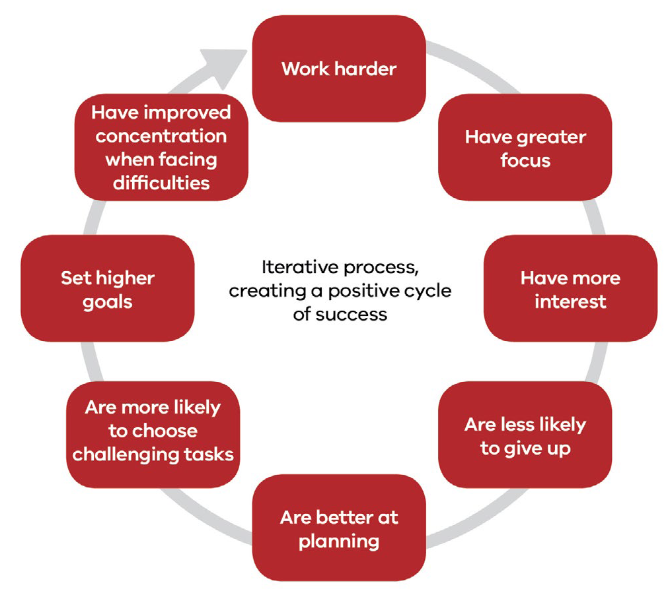The partnerships between schools and families are incredibly impactful throughout students’ school years. Incorporated in productive ways, these relationships have the potential to:
Students with a strong sense of agency...

Figure 4: Generating a positive cycle of learning (Johnston 2004).
- support differentiated instruction and study at home
- improve student outcomes
- enhance satisfaction for all stakeholders (Forlin & Hopewell 2006).
It is important that teachers are proactive in their communication with families and acknowledge the contribution that parents, guardians and carers make in a child’s development.
This is crucial, since research demonstrates a clear and positive relationship between family involvement at home and students’ academic achievement (Bakker et al. 2013; Castro et al. 2015).
To achieve a positive relationship it is important that families have confidence in their child’s teachers, feel welcome at school and experience reciprocity in their communications with school (Epstein 2018).
Establishing this relationship comes with challenges, and barriers can exist that hinder a constructive relationship between school staff and families.
As individuals who are familiar with the cultures of both home and school, it is important to consider how to involve students in this process to help bridge potential barriers and achieve a positive and productive partnership.
For more information visit Building positive partnerships with parents (www.education.gov.au/ family-school-partnerships-1)

Bibliography and professional reading

Australian Federation of SPELD Associations [AUSPELD] 2019, Understanding Learning Difficulties, retrieved 22 August 2019,
<http://auspeld.org.au/>.
Bakker, J, Denessen, E, Denessen, M & Oolbekkink- Marchand, H 2013, A review of studies on the effectiveness of parental involvement and the role of teachers, Radboud University Nijmegen, Nijmegen, The Netherlands.
Buffum, A, Mattos, M, Weber, C 2012, Simplifying response to intervention: four essential guiding principles, Solution Tree Press, Bloomington.
Butterworth, B 2019, Dyscalculia: From Science to Education, Routledge, London.
Castro, M, Exposito-Casas, E, Lopez-Martin, E, Lizasoain, L, Navarro-Asencio, E, & Gaviria, J 2015, ‘Parental involvement on student academic achievement: A meta-analysis’, Educational Research Review, vol. 14, no. 1, pp. 33-46.
Epstein, J 2018, ‘School, family, and community partnerships in teachers’ professional work’, Journal of Education for Teaching, vol. 44, no. 3, pp. 397-406.
Forlin, C & Hopewell, T 2006, ‘Inclusion – the heart of the matter: Trainee teachers’ perceptions of
a parent’s journey’, British Journal of Special Education, vol. 33, no. 2, pp. 55-61.
Fuchs, L, Fuchs, D, Powell, S, Seethaler, P, Cirino, P, & Fletcher, J 2008, ‘Intensive Intervention for Students with Mathematics Disabilities: Seven
Principles of Effective Practice’, Learning Disability Quarterly, vol. 31, no. 2, pp. 79-92.
Gettinger, M & Stoiber, K 2007, ‘Applying a Response-to-Intervention Model for Early Literacy Development in Low-Income Children’, Topics in Early Childhood Special Education, vol. 27, no. 4, pp. 198-213.
Hattie, J 2009, Visible Learning: A Synthesis of Over 800 Meta-analyses Relating to Achievement, Routledge, Milton Park.
Howell, A 2009, ‘Flourishing: Achievement-related correlates of students’ well-being’, The Journal of Positive Psychology, vol. 4, no. 1, pp. 1-13.
Johnston, P 2004, Choice words: How our language affects children’s learning, Stenhouse Publishers, Portland.
Landerl, K 2019, ‘Neurocognitive perspectives on numerical development’, in A Fritz, V Hasse, & P Räsänen (Eds.), International handbook of math learning difficulties: from the lab to the classroom Springer Nature International, Cham, Switzerland, pp. 9-24.
Marston, D 2005, ‘Tiers of intervention in responsiveness to intervention: Prevention outcomes and learning disabilities identification patterns’, Journal of learning disabilities, vol. 38, no. 6, pp. 539-544.
Nationally Consistent Collection of Data on School Students with Disability [NCCD] 2019, Disability standards for Education, retrieved 22 August 2019,
<https://www.nccd.edu.au/resources-and-tools/
professional-learning/format/e-learning-5>.
Reeve, R 2019, ‘Math learning difficulties in Australia’, in A Fritz, V Hasse, & P Räsänen (Eds.), International handbook of math learning
difficulties: from the lab to the classroom, Springer Nature International, Cham, Switzerland, pp. 253-
264.
Reeve, R, & Waldecker, C 2017, ‘Evidence based assessment and intervention for dyscalculia and math disabilities’, in M Thielking & M Terjesens (Eds.), Handbook of Australian school psychology, Springer International, pp. 197-213.
Suldo, S, Thalji, A, & Ferron, J 2011, ‘Longitudinal academic outcomes predicted by early adolescents’ subjective well-being, psychopathology, and mental health status
yielded from a dual factor model’, The Journal of Positive Psychology, vol. 6, no. 1, pp. 17-30.
Victorian Curriculum and Assessment Authority [VCAA] 2019, Numeracy, VCAA, Melbourne.
Williams, P 2017, ‘Student agency for powerful learning’, Knowledge Quest, vol. 45, no. 4, pp. 9-16.

Appendix 1.1

High Impact Teaching Strategy
- Structuring Lessons

This strategy is demonstrated when students:

• understand the learning goals and success criteria

Effective teachers plan and deliver structured lessons which incorporate a series of clear steps and transitions between them, and scaffold learning to build students’ knowledge and skills.
A lesson structure maps teaching and learning that occurs in class. Sound lesson structures reinforce routines, scaffold learning via specific steps/activities, and optimise time on task and classroom climate using smooth transitions.
Planned sequencing of teaching and learning activities stimulates and maintains engagement by linking lesson and unit learning.

How effective is it?
The way teachers structure lessons has a significant impact on student learning. Research shows student achievement is maximised when teachers structure lessons so that they:
  - begin with overviews and/or review objectives
  - outline the content to be covered and signal transitions between lesson parts
  - call attention to main ideas
  - review main ideas at the end
A sound lesson structure contributes to effective scaffolding of student learning.

This strategy is demonstrated when the teacher:
  - explains to students the steps in the lesson, including presenting learning intentions, explicitly presenting new knowledge, identifying planned opportunities for practice, outlining questioning techniques the class will use and describing the assessment formats
  - makes clear connections between the learning goals, activities and assessment tasks
  - creates transparent, predictable and purposeful routines for students
  - identifies clear transitions between each step in the lesson
  - plans the sequence of steps to scaffold student learning
  - monitors student understanding and provides feedback.
- understand the lesson routine and confidently negotiate the sequence of steps/activities.

This strategy is not demonstrated when:
- lesson structures keep changing, producing unhelpful unpredictability in the
classroom environment.

Resources:
- Well-sequenced mathematics teaching
www.youtube.com/watch?v=gijBHH0Z8M0)
- Birth to Level 10 Numeracy Guide – Structuring Lessons www.numeracyguidedet.global2.vic.edu.au/ hits-structuring-lessons
- Australian Curriculum – Numeracy www.australiancurriculum.edu.au/f-10- curriculum/general-capabilities/numeracy

Appendix 1.2

High Impact Teaching Strategy
- Explicit Teaching

This strategy is demonstrated when students:

• understand the learning goals and success criteria

Effective teachers use explicit teaching to provide instruction, demonstrate concepts and build student knowledge and skills. In explicit teaching practice, teachers show students what to do and how to do it, and create opportunities in lessons for students to demonstrate understanding and apply the learning.

Strategy overview
When teachers adopt explicit teaching practices they clearly show students what to do and how to do it. Students are not left to construct this information for themselves. The teacher decides
on learning intentions and success criteria, makes them transparent to students, and demonstrates them by modelling. In addition, the teacher checks for understanding, and at the end of each lesson revisits what the lesson has covered and ties it all together (Hattie, 2009).

How effective is it?
Explicit teaching is effective in accelerating student performance. The aim is to teach generalisations beyond rote learning, and to sequence learning. In explicit teaching practice, teachers constantly monitor students’ progress towards challenging goals. The effects of explicit teaching are similar for students in all school settings. In addition to numeracy, explicit teaching also has the highest effect size for reading among students at every year level. It supports both low and high level comprehension.

This strategy is demonstrated when the teacher:
  - explains what students need to know and be able to do by the end of the lesson or unit
  - uses worked examples to show students how to do something
  - allows students sufficient time to practice what they have learned
  - guides student practice by monitoring their work and providing help when it is needed
  - reinforces the main points at the end of the lesson.
- have access to multiple examples before undertaking the learning task
- master the new knowledge and skills before moving on
- receive feedback as needed.

This strategy is not demonstrated when:
- the teacher is didactic, with few opportunities for students to be active in the learning
- classroom discussion is restricted and student input is discouraged
- the teacher responds judgmentally to students’ attempts at problem solving activities rather than treating each attempt as an opportunity for further learning.

Resources:
- AITSL – Explicit instruction
www.youtube.com/watch?v=t4zuYXLodRA
- Birth to Level 10 Numeracy Guide – Explicit Teaching www.numeracyguidedet.global2.vic.edu.au/ hits-explicit-teaching

